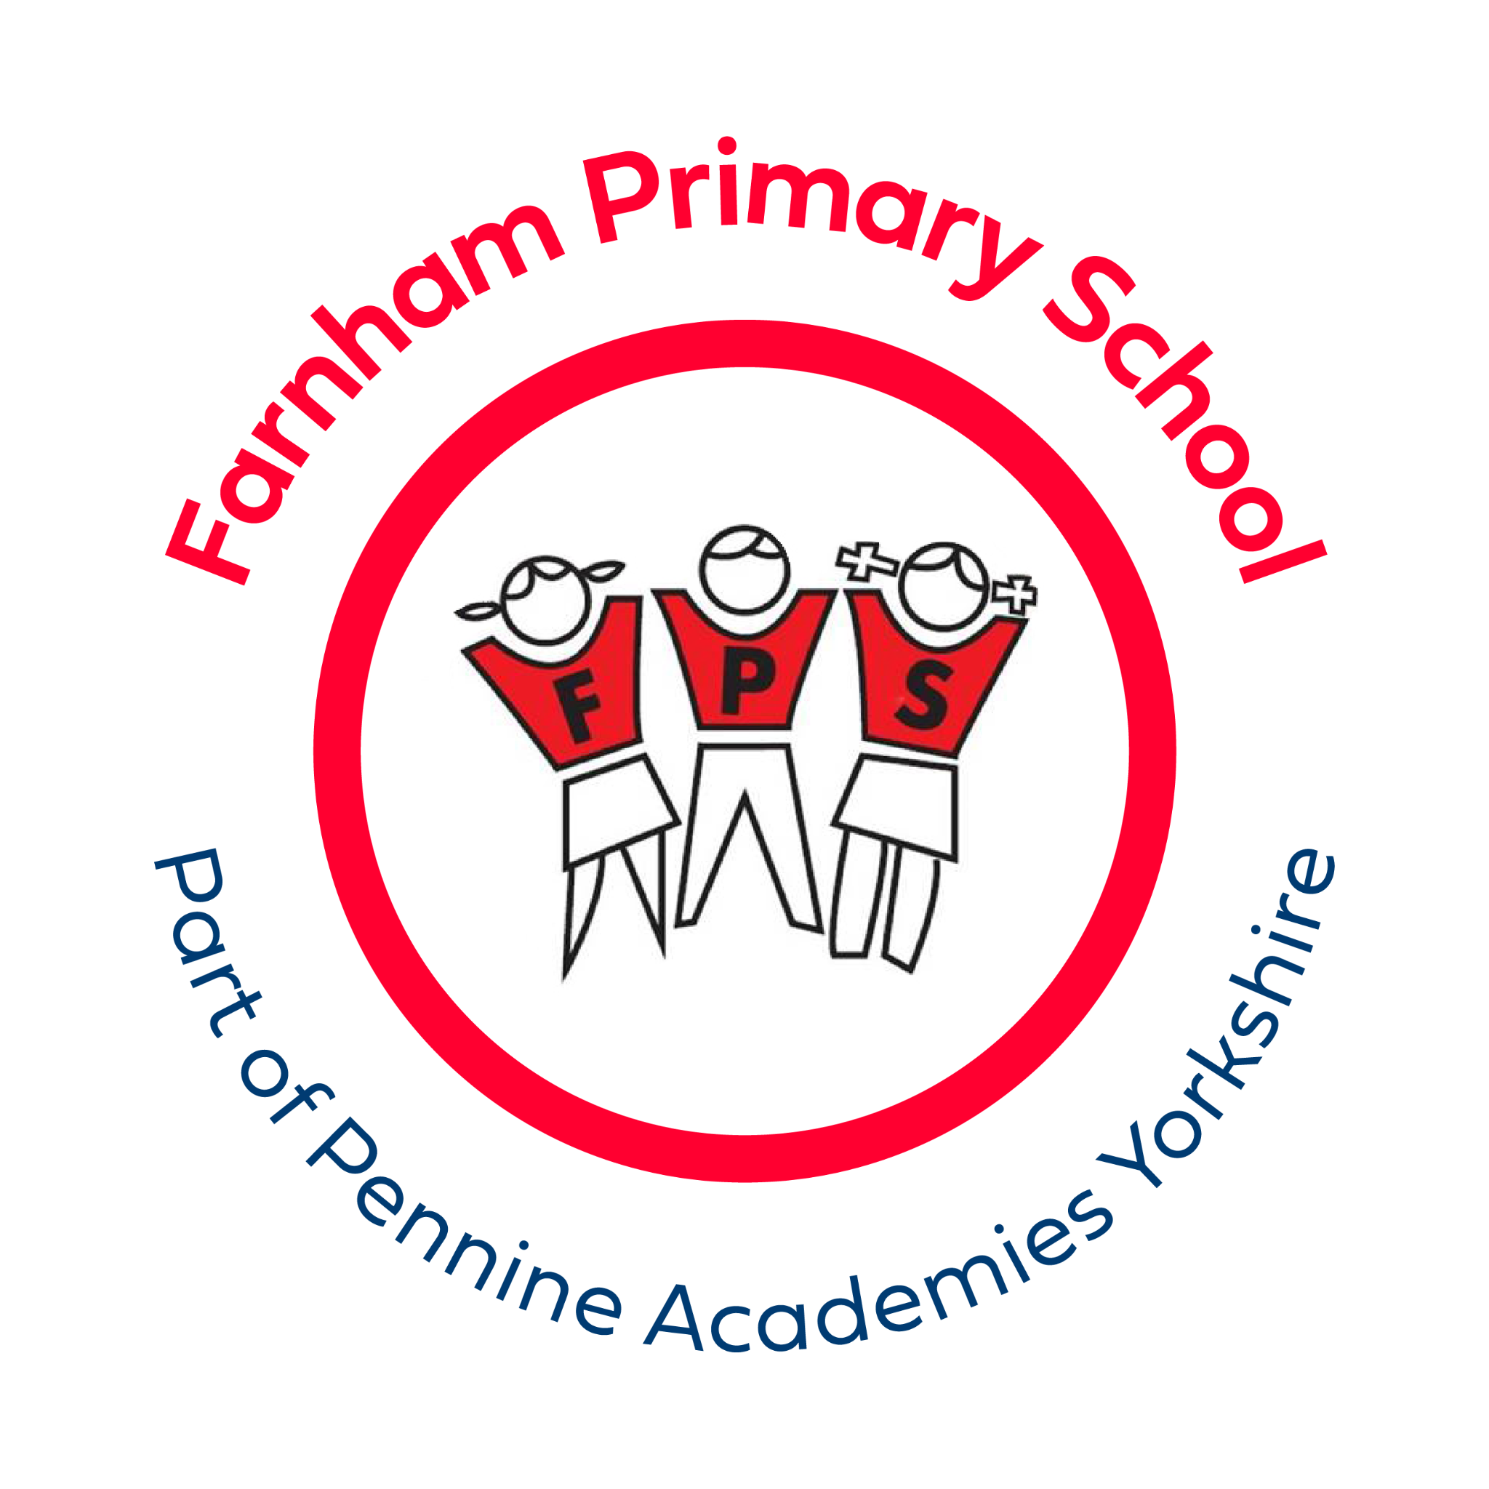
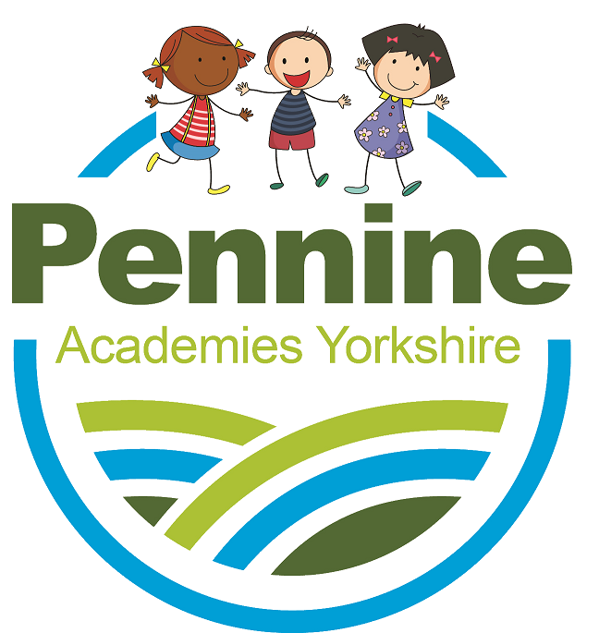
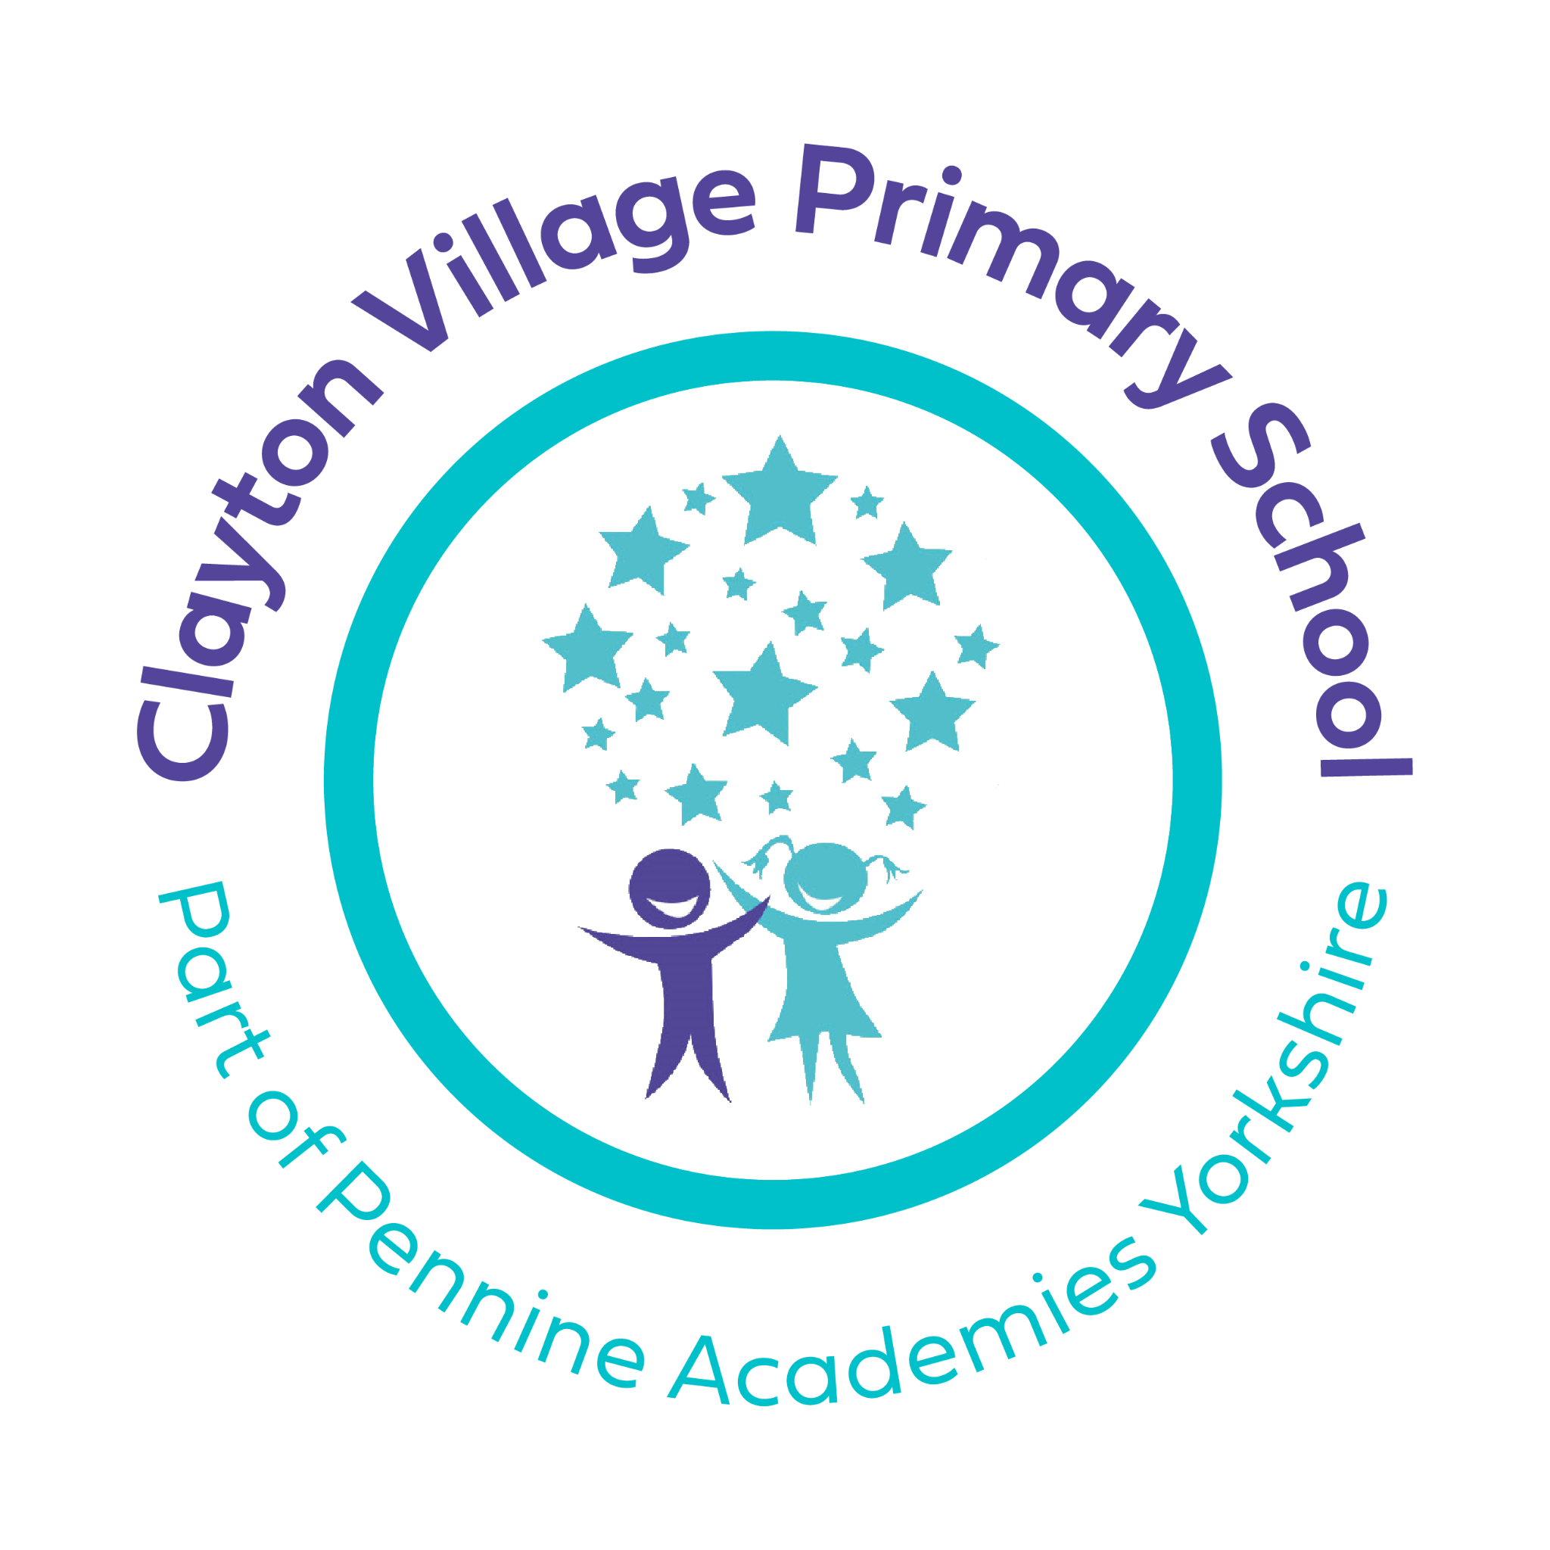

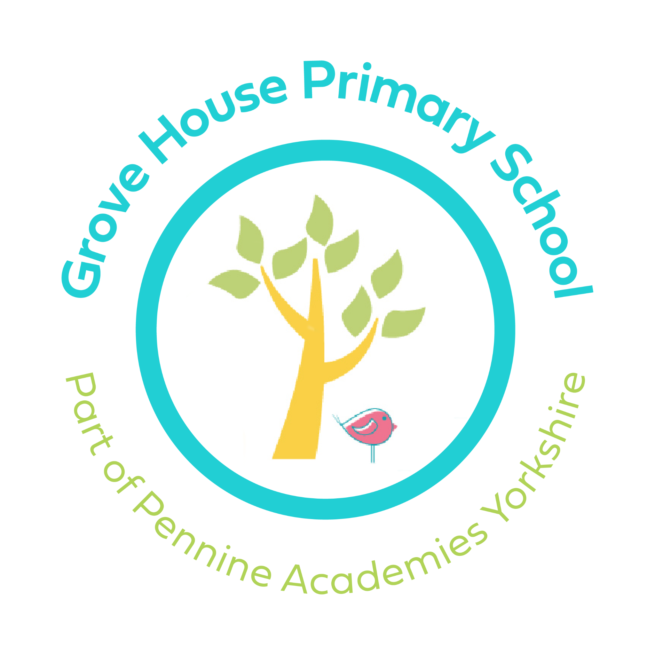
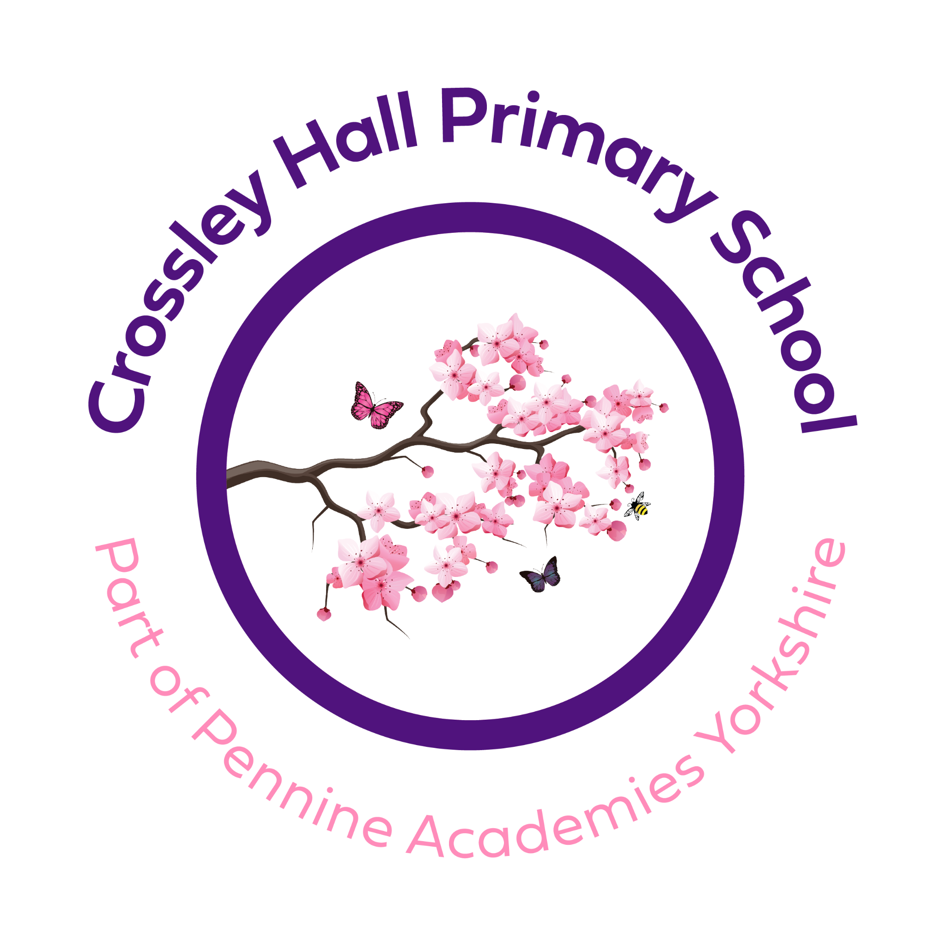

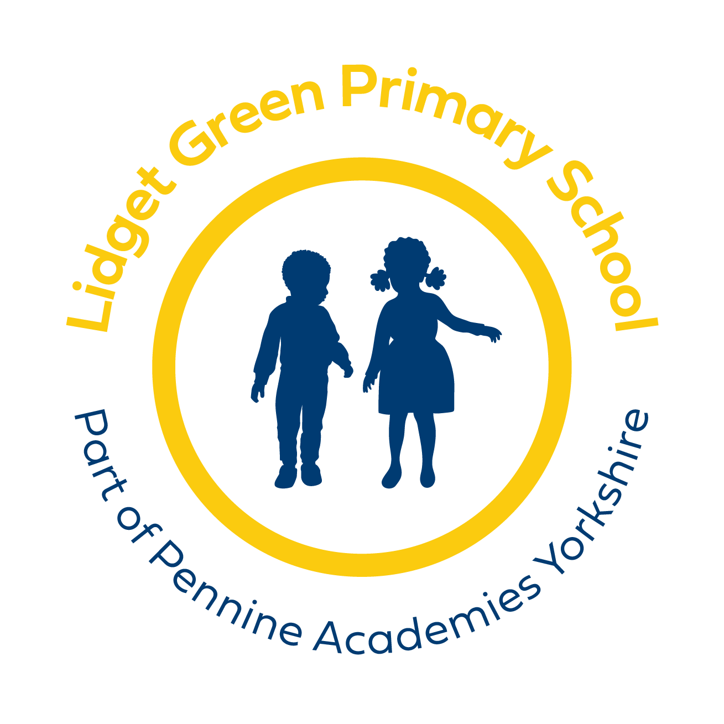
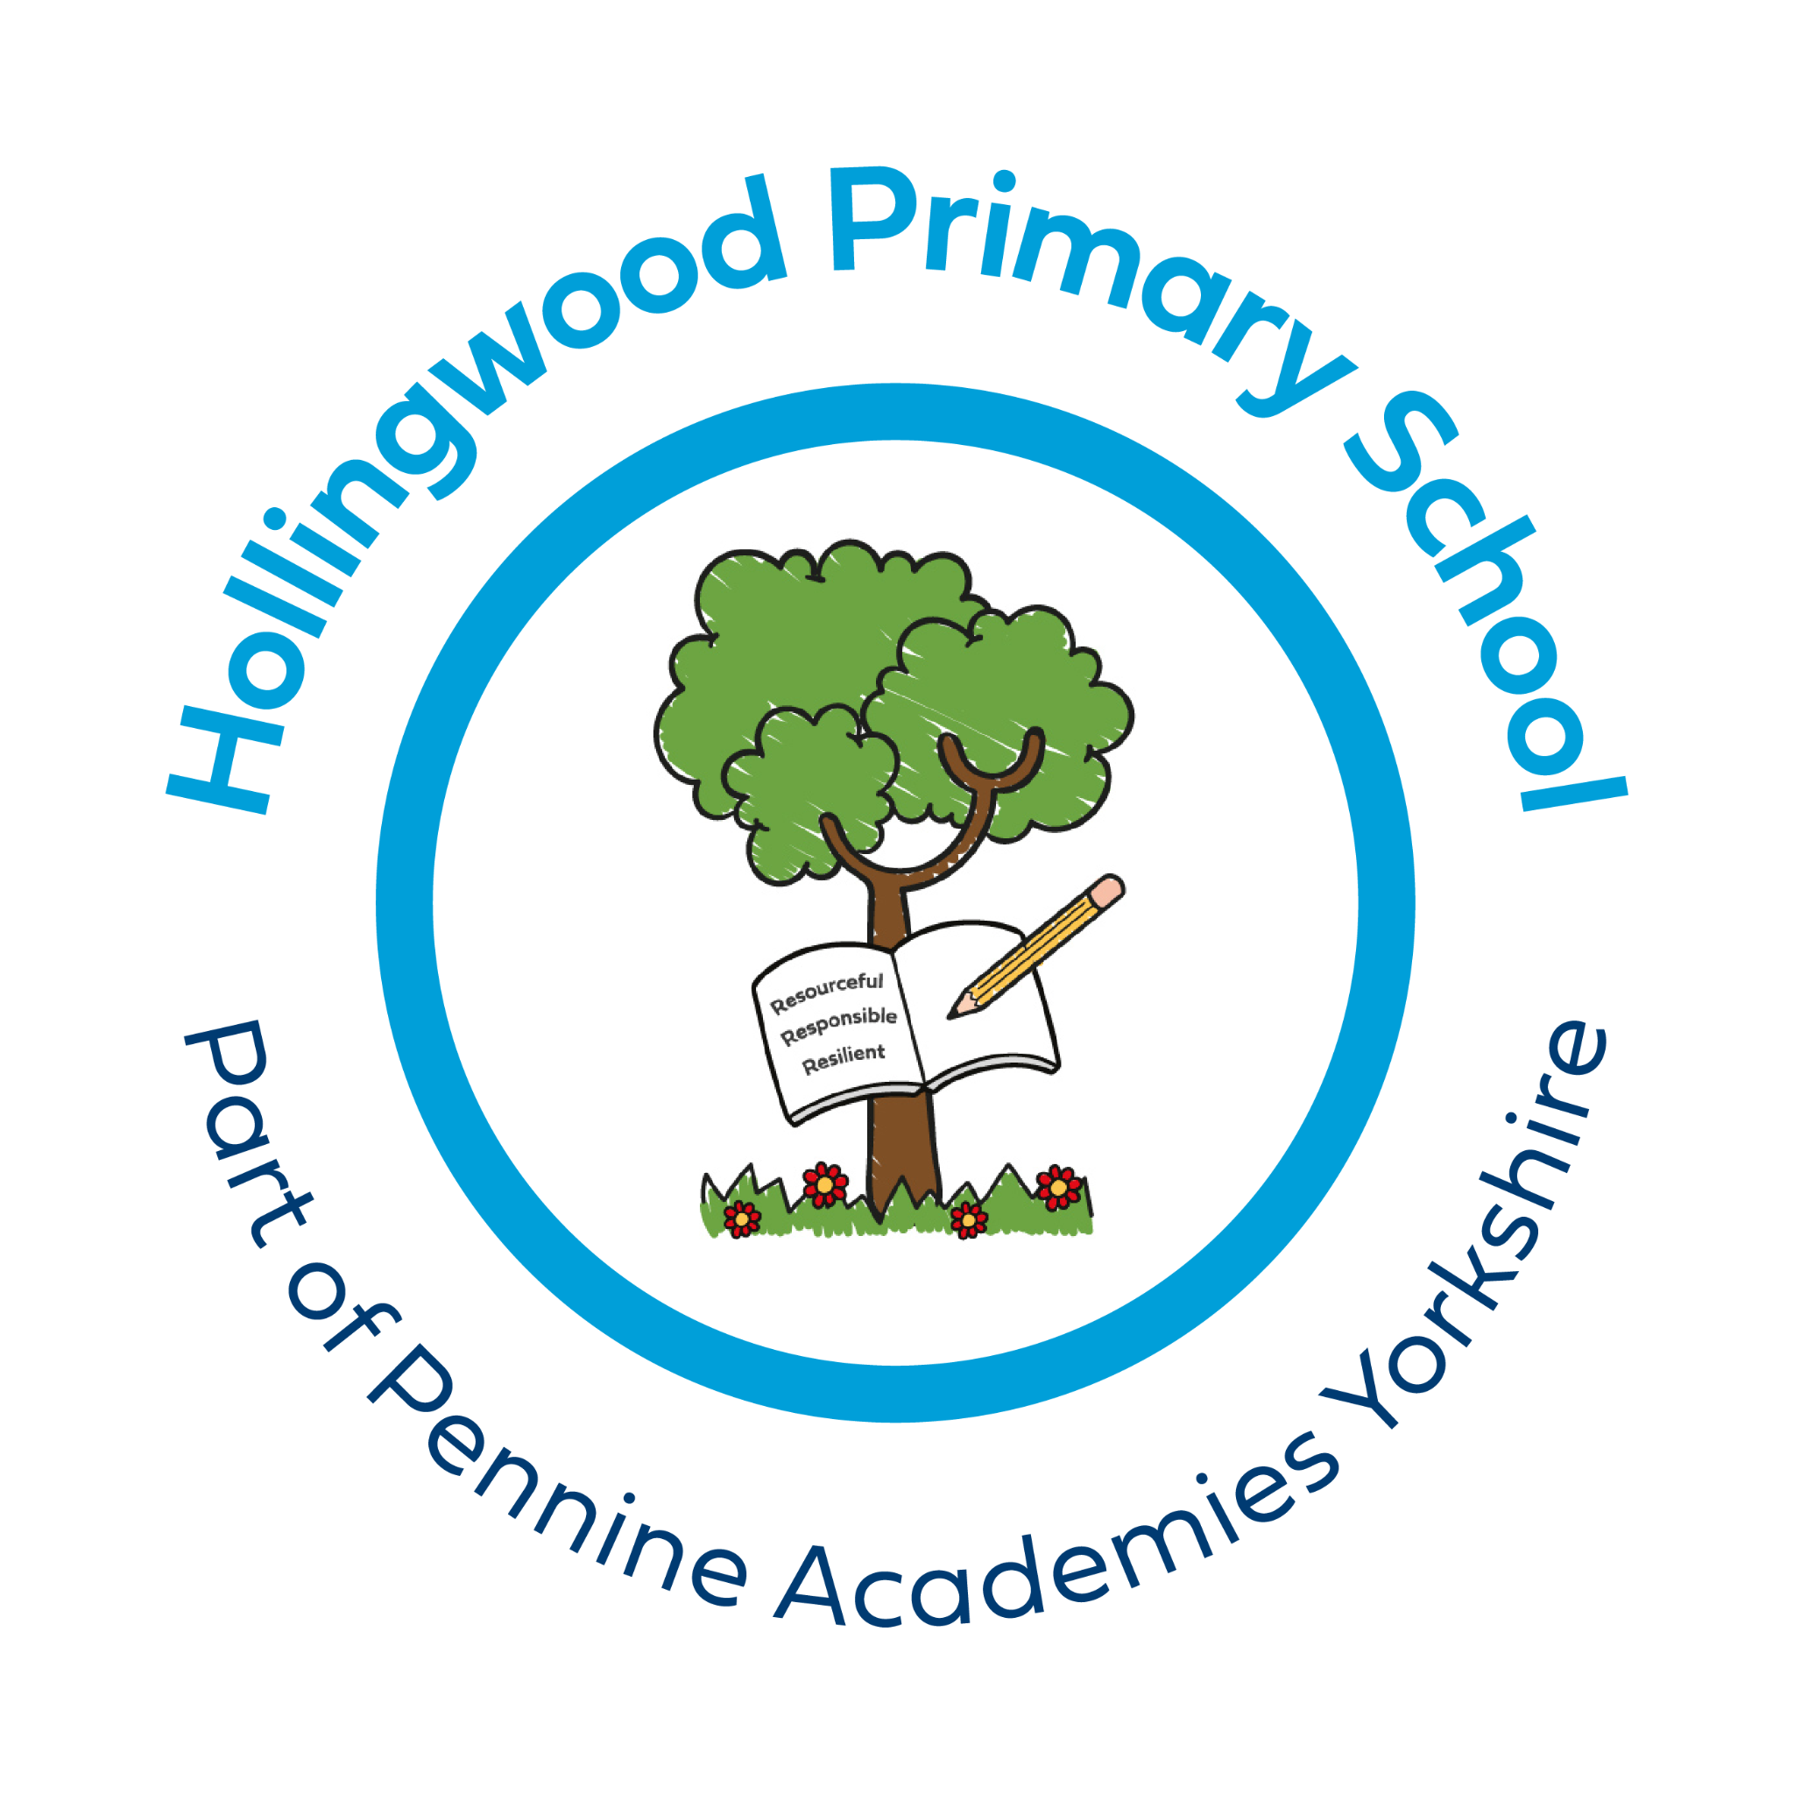
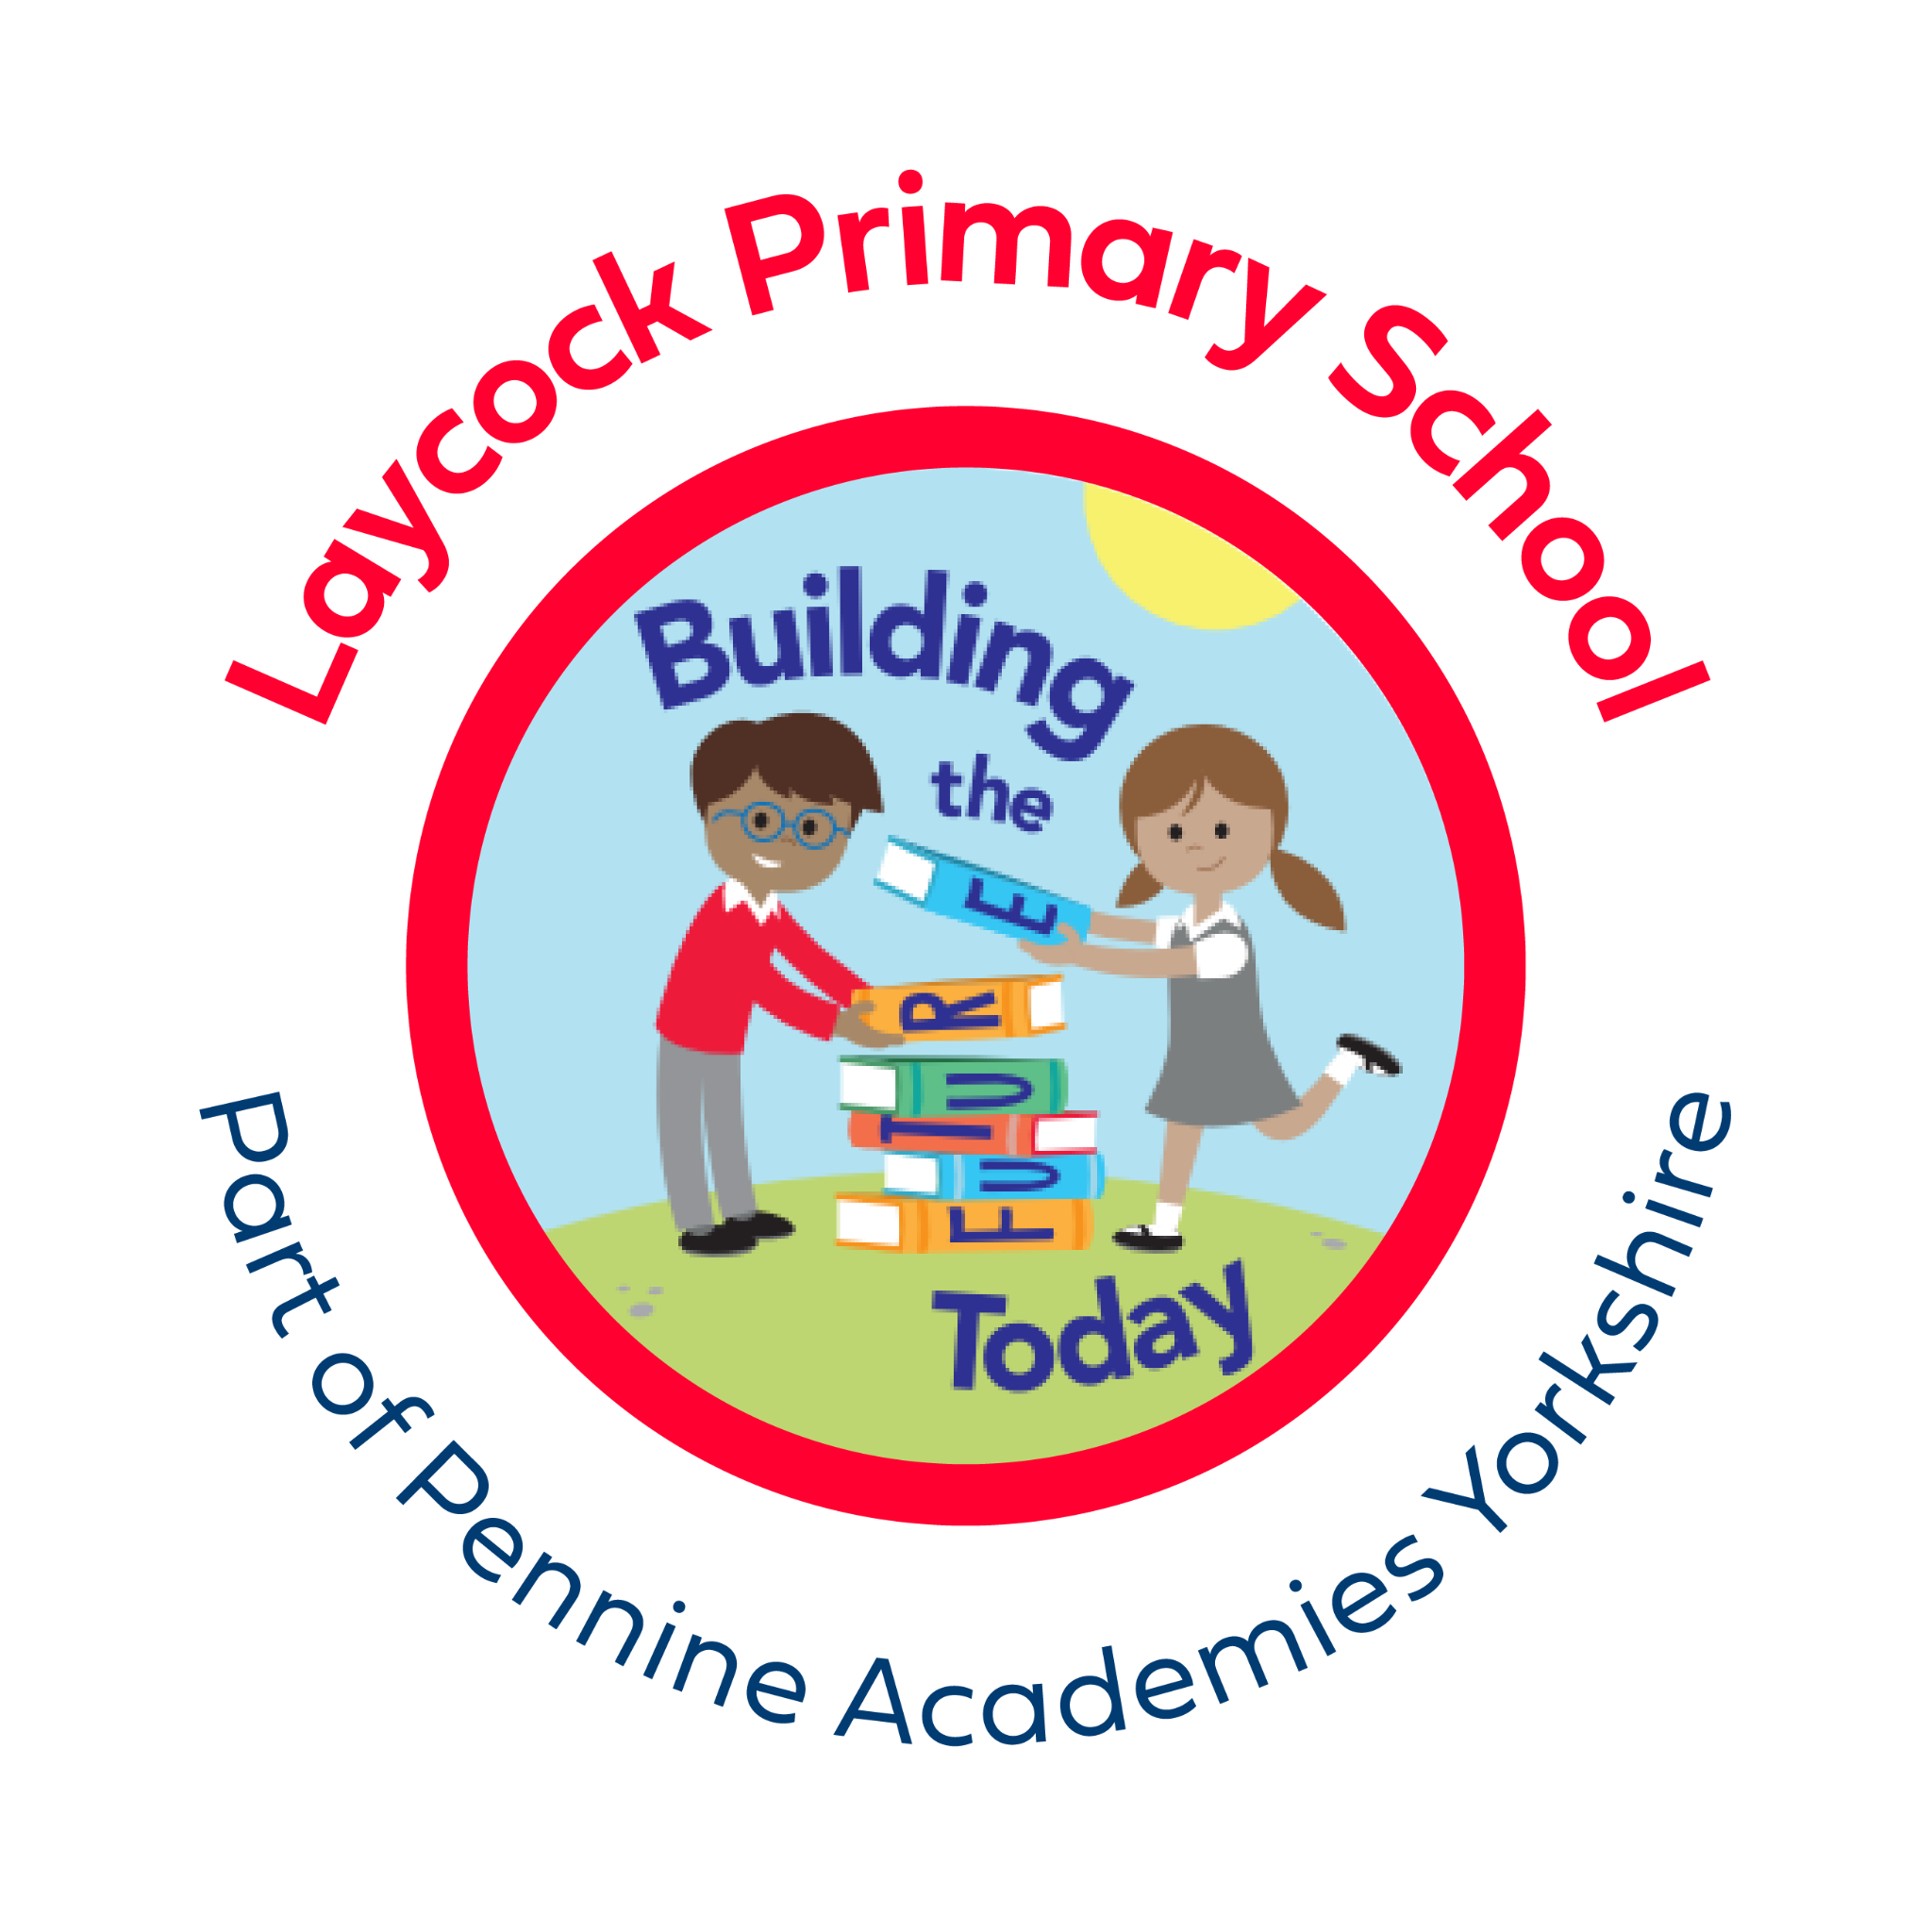

PARENT PARLIAMENT 2024 - 2025

Dear Parents,

As you know your child attends a school that is part of a family of schools called Pennine Academies Yorkshire.

Pennine appreciates that parents have an essential role to help us to ensure all of our students are successful. The Pennine Parent Parliament is our way to ensure that parents have a clear voice in the way that the schools function. It is your opportunity to discuss key topics with the chance to ask questions or raise any other concerns.

You as parents are an important stakeholder in the success of our students and offer a valuable contribution to how we can best guide our children to reach their full potential. To enable parents to have the opportunity to present their ideas, both on current issues and ideas for future development, we host our ‘Parents Parliament’ every term.

Reasons to get involved:

- A chance to share your school experience with Senior Leaders and each other
- A chance to learn more about the Trust
- You’ll get to meet other parents from your school and other schools
- An opportunity to learn more about the schools and the Trust
- An opportunity to be involved in shaping the future of the Trust

If you think you would be interested in getting involved or would like more information then please either speak to the school office, headteacher or email directly to getinvolved@paymat.org.

Thank you in advance for your interest.

Michael Thorp
Chief Executive Officer
Pennine Academies Yorkshire

