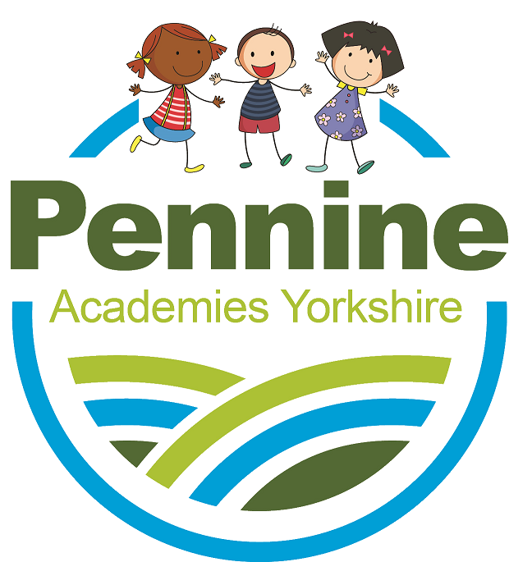
JOB DESCRIPTION PARENT PARLIAMENT

GENERIC INTRODUCTION

Pennine Academies Yorkshire (PAY) is a Multi Academy Trust comprising several local primary schools.

It is essential that we have representation from parents of each of our academies. To this end we have created a virtual Parent Parliament committee. This body is made up of 2 parent representatives from each of the academies, the Chief Executive of the Trust and appropriate Central Team staff. This committee meeting provides a vehicle of two-way communication to allow the Trust to inform parents of school and Trust evaluation, next developmental steps and successes.

Parents in turn will have an opportunity to feed into the Trust Development Plan, provide feedback on what they see as next steps for individual schools and any input into what schools or the Trust could be doing better. This will be reported back to the Trust Board by the lead Trustees.

Parent Parliament Role Expectations

Members of the Parent Parliament give invaluable feedback regarding the “customer experience” received from PAY.

- It is imperative that Parent Parliament members give generic feedback and not specific feedback regarding their own child(ren)

- The Chief Executive will meet with the Parent Parliament reps of each school in turn throughout the course of the year.

