Dear Parents/Carers and friends,
Donations for break and lunch times!
We are creating a lovely role-play/drama area outside our Y2 classroom. We need your help!
Any donations towards the following would help make our area a success:
Top hats/Any kids of hats | Sashes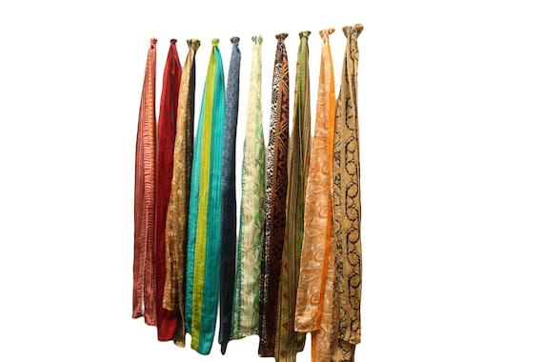 | Sequined/sparkly clothes/suit jackets  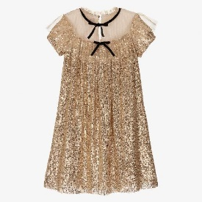
Any general role-play clothing  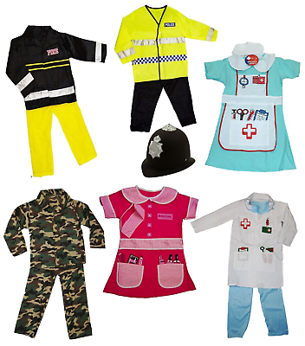 | Bags/suitcases  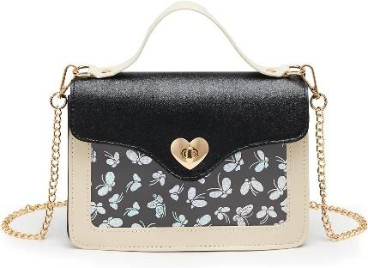  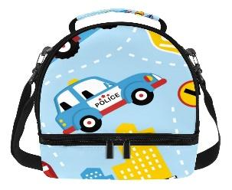 | Sunglasses/dressing up accessories  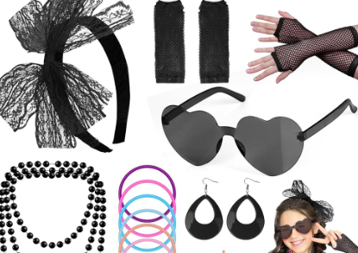
Super hero masks/capes | Costumes  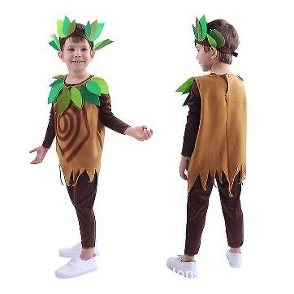 | Drama props  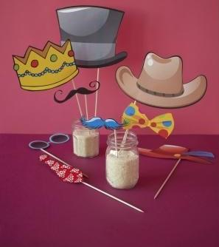

Please drop any items you are able to donate at the school office.

Thank you in advance for all of your support.
Yours sincerely,
Mr C Wickett

