Reception
Topic | Exploring Sound |  | Celebration music |  | Transport |  | Music and movement |  | Musical stories |  | Big band
Linked books | 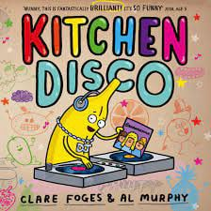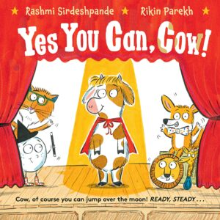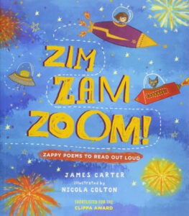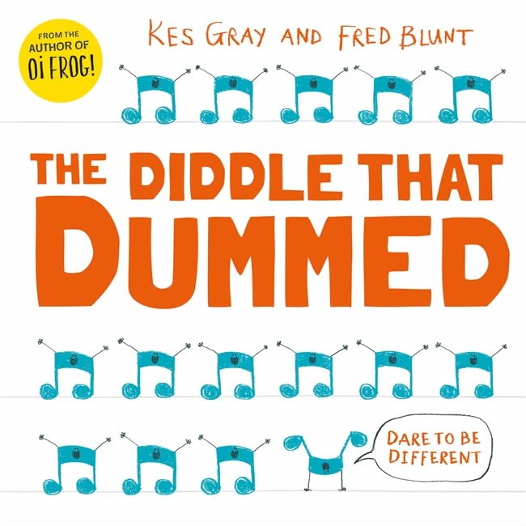
Curriculum end point | ELG: Listening, Attention and Understanding  Children at the expected level of development will:  Listen attentively and respond to what they hear with relevant questions, comments and actions when being read to and during whole class discussions and small group interactions.  ELG: Being Imaginative and Expressive  Sing a range of well-known nursery rhymes and songs; Perform songs, rhymes, poems and stories with others, and – when appropriate – try to move in time with music.
 | Music Focus:  Children explore how they can use their voice and bodies to make sounds, experiment with tempo and dynamic when playing instruments, identify sounds in the environment and differentiate between them. |  | Music Focus:  Learning about the music from a range of cultural and religious celebrations, including Diwali, Hanukkah, Kwankzaa and Christmas. |  | Music Focus:  Using their voices, bodies and instruments to explore different types of transport, identify and mimic transport sounds and interpret and perform a simple score. |  | Music Focus:  Creating simple actions to songs, learning how to move to a beat and expressing feelings and emotions through movement to music. |  | Music Focus:  A unit based on traditional childrens’ tales and songs, where pupils learn that music and instruments can be used to convey moods or represent characters. |  | Music Focus:  Learning about the four different groups of musical instruments, following a beat using an untuned instrument and performing a practised song to a small audience.
Skills
Composing | Playing untuned percussion ‘in time’ with a piece of music.  Selecting classroom objects to use as instruments.  Experimenting with body percussion and vocal sounds to respond to music.  Selecting appropriate instruments to represent action and mood.  Experimenting with playing instruments in different ways.
Performing | Using their voices to join in with well-known songs from memory.  Remembering and maintaining their role within a group performance.  Moving to music with instruction to perform actions.  Participating in performances to a small audience.  Stopping and starting playing at the right time.
Vocabulary | voice, voice sounds, sound, instrument, loud, quiet, high, low, squeaky, soft, deep, body sounds, body percussion, sound, tempo, fast, slow, rhythm, beat, instrumental sounds, tempo, fast, quickly, slowly, dynamic, loudly, quietly, environmental sounds, pitch, middle, nature sounds | music, dance, tempo, move, Diwali, celebration, traditional, Hanukkah, Hora, kinnor, harp, flute, Jewish, trumpet, cymbals, tambourine, shofar, Kwanzaa, Africa, culture, call, response, drum, rhythm, beat, instrument, Christmas, Christian, sleigh bells, actions, action songs, voice sounds, body percussion |  | car, boat, train, beat, fast, slow, speed, cruise, rowing, water, symbols, slower, faster, stopping, journey, score |  | actions, action songs, sign language, Makaton, deaf, communication, communicating, understand, lyrics, verse, beat, music, heartbeat, pulse, steady, repeat, constant, drum, piece, composer, tempo, fast, moderate, medium, slow, dance, pitch, high, low, sound, whistle, triangle, siren, cello, perform, performance, audience |  | classical music, pitch, high, low, tempo, fast, slow, dynamic, loud, quiet, musical story, lyrics, melody, character, instrument, song, actions, percussion, compose, perform, performance |  | music, musical instrument, band, sound, shake, tap, bang, strum, jingle, tempo, dynamic, pitch, beat, orchestra, sound, rhythm, beat, conductor, wind, strings, percussion, brass

