 | Nursery
Exposure through songs | Core nursery rhymes  Baa Baa Black sheep  Old Mac Donald  Twinkle Twinkle  Wind the bobbin up  Roly Poly Roly  Incy wincy spider  The wheels on the bus  Rainbow song  I have a little spider  Three speckled frogs  Food Train  Petrol in the car
Exposure through stories | 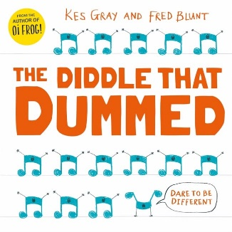  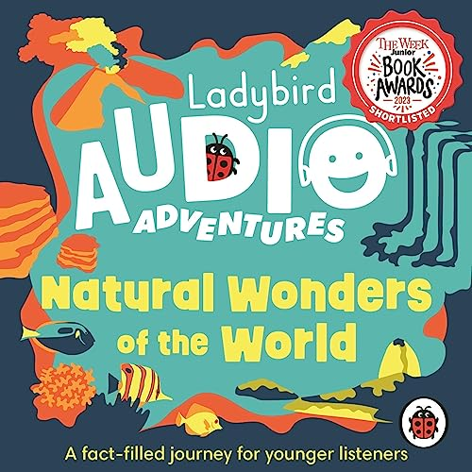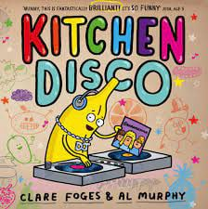
Learning through child initiated learning | Music wall  Rhyme and music area  Outdoor music  World Nursery rhyme week  Rhymes to gain children’s attention  Rhyme books

