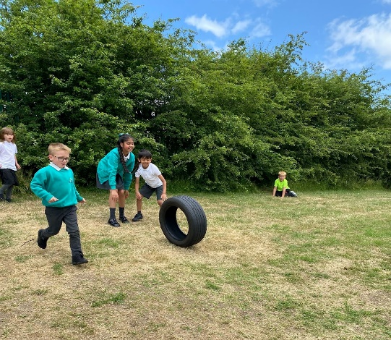
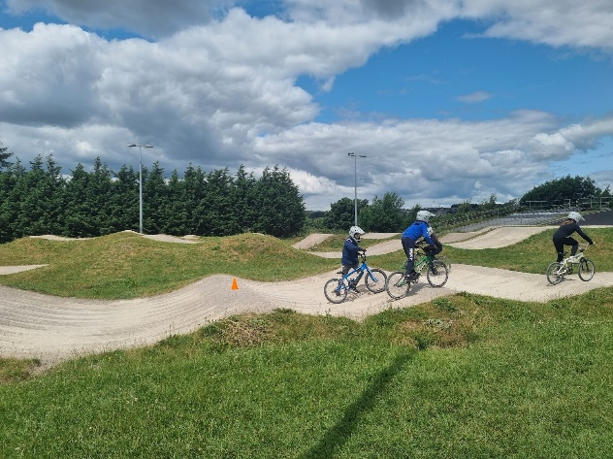
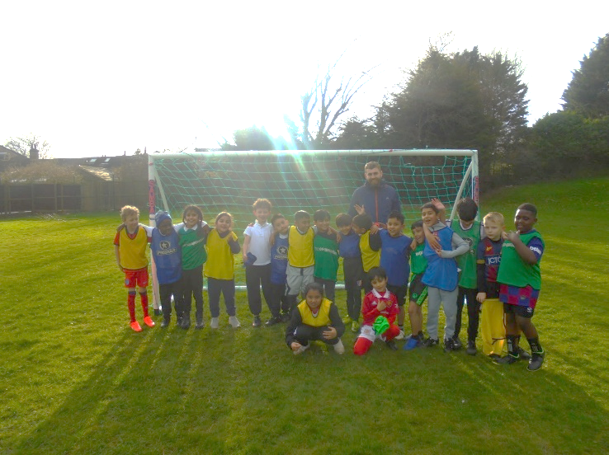
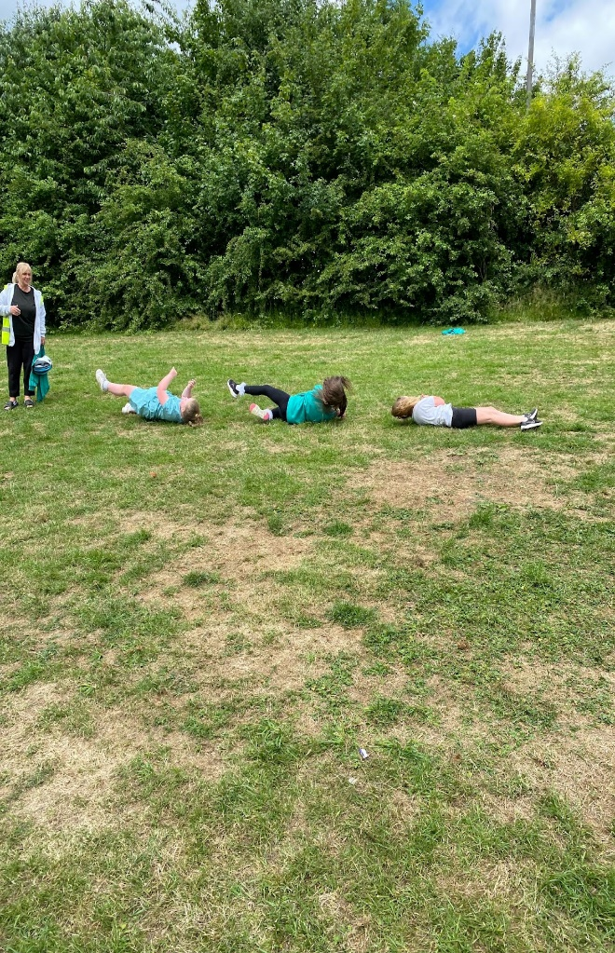
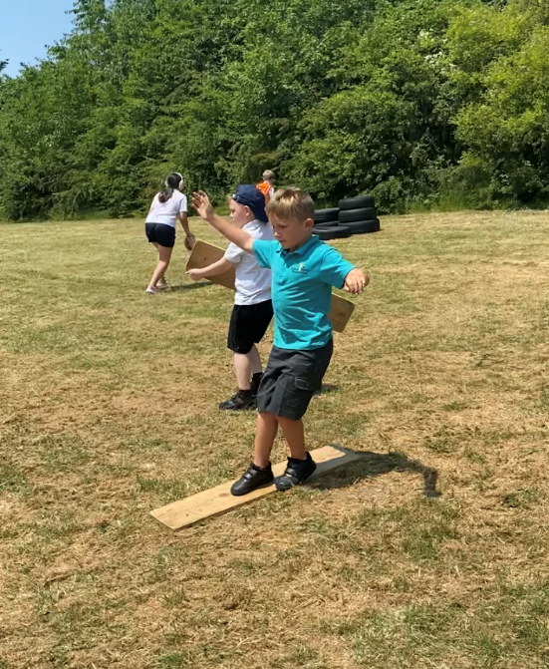
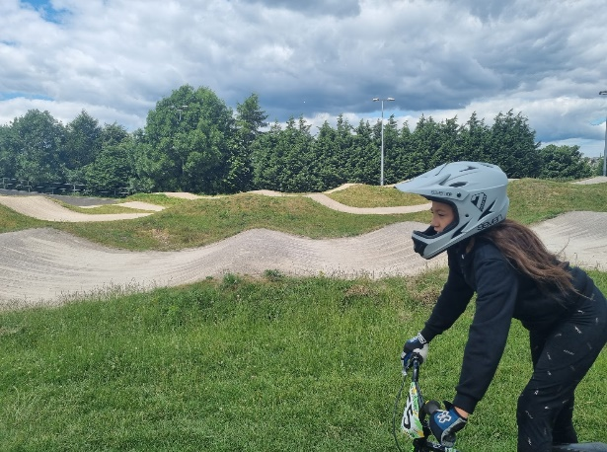
Grove House Primary School
Sports Funding Report 2022-2023

Total amount carried over from 2021/22 | £0
Total amount allocated for 2021/22 | £16,243
How much (if any) do you intend to carry over from this total fund into 2022/23? | £0
Total amount allocated for 2022/23 | £19,490
Total amount of funding for 2022/23. Ideally should be spent and reported on by 31st July 2023. | £19,490

Meeting national curriculum requirements for swimming and water safety.

N.B. Complete this section to your best ability. For example you might have practised safe self-rescue techniques on dry land which you can then transfer to the pool when school swimming restarts.
Due to exceptional circumstances priority should be given to ensuring that pupils can perform safe self rescue even if they do not fully meet the first two requirements of the NC programme of study
What percentage of your current Year 6 cohort swim competently, confidently and proficiently over a distance of at least 25 metres?  N.B. Even though your pupils may swim in another year please report on their attainment on leaving primary school at the end of the summer term 2023.  Please see note above | 59%%
What percentage of your current Year 6 cohort use a range of strokes effectively [for example, front crawl, backstroke and breaststroke]?  Please see note above | 48%%
What percentage of your current Year 6 cohort perform safe self-rescue in different water-based situations? | 40%
Schools can choose to use the Primary PE and sport premium to provide additional provision for swimming but this must be for activity over and above the national curriculum requirements. Have you used it in this way? | No

Academic Year: 2022/23 | Total fund allocated: | Date Updated:
Key indicator 1: The engagement of all pupils in regular physical activity – Chief Medical Officers guidelines recommend that primary school pupils undertake at least 30 minutes of physical activity a day in school |  |  |  | Percentage of total allocation:
 |  |  |  | %
Intent | Implementation |  | Impact
Your school focus should be clear what you want the pupils to know and be able to do and about  what they need to learn and to  consolidate through practice: | Make sure your actions to achieve are linked to your intentions: | Funding allocated: | Evidence of impact: what do pupils now know and what can they now do? What has changed?: | Sustainability and suggested next steps:
Appoint professional, experienced sports coach to support staff CPD and improve quality of teaching and learning in PE lessons and lunch time play.  Increase amount of time dedicated to physical activity.  Introduce children to a wider range of physical activities including team sports and individual sports.  Use JU:MP funding to develop outdoor active learning. | Sports coach to work with teachers and support staff to model effective planning and teaching of the PE curriculum as well as support students and lunch time staff in leading positive active play at lunch times.  PE timetable revised to include two PE lessons each week, one of which is dedicated to fitness.  Lunchtime timetable adapted so that less children are out at the same time allowing more children to access a wider range of physical activities.  Climbing wall installed + outdoor creative shed.  Scooters and helmets purchased. | £18,000  £10,000 JU:MP funding additional | Teacher and support staff sports specific skill knowledge has improved. Pupil engagement in PE lessons and attitude towards sports is positive. | 100%
Key indicator 2: The profile of PESSPA being raised across the school as a tool for whole school improvement |  |  |  | Percentage of total allocation:
 |  |  |  | %
Intent | Implementation |  | Impact
Your school focus should be clear what you want the pupils to know and be able to do and about  what they need to learn and to  consolidate through practice: | Make sure your actions to achieve are linked to your intentions: | Funding allocated: | Evidence of impact: what do pupils now know and what can they now do? What has changed?: | Sustainability and suggested next steps:
Alternative outdoor play strategies have trialled to improve engagement in positive active play.  Lunch time timings revised to provide more opportunity for children to engage in a wider variety of outdoor play and to enable more support staff to support outside at lunch times.  Active learning strategies in academic  Lessons encouraged with children participating in an active learning model. | Playground areas ‘zoned’ and staff allocated areas of responsibility to direct play and encourage children to play positively.  Kindness committee in place to encourage children to support each other and begin to resolve difficulties independently.  Children from year six assigned to ‘school workforce’ to support younger children in the dining hall and outside in positive play activities.  Classroom pedagogy reflects active learning model with opportunities for ‘brain breaks’ and active breaks to ensure children are aware of how their mental and physical heath are linked.  All staff who support lunchtime play had training on how to build on play positively though effective questioning and language use.  Parent workshop and communication to introduce play time strategy and explain the research behind it. | Jump funding utilised | Children are more able to make choices about what type of play they would like to engage in. Staff are clear about their responsibilities outside and how to support children’s play positively which has increased confidence.  Parents have a better understanding of how break and lunch time play operates.  The majority of parents are supportive of the outdoor active play strategy.  Lunch time behavior incidents have reduced. | Engage opal outdoor active play strategy and undertake whole staff training.  Engage ‘Commando Joe’ to support team building and collaboration in positive play.

Key indicator 3: Increased confidence, knowledge and skills of all staff in teaching PE and sport |  |  |  | Percentage of total allocation:
 |  |  |  | %
Intent | Implementation |  | Impact
Your school focus should be clear | Make sure your actions to | Funding | Evidence of impact: what do | Sustainability and suggested
what you want the pupils to know | achieve are linked to your | allocated: | pupils now know and what | next steps:
and be able to do and about | intentions: |  | can they now do? What has
what they need to learn and to |  |  | changed?:
Teachers receive training on teaching sport specific skills from our Bradford City Coach through team teaching and coaching model.  Teacher’s knowledge, confidence and quality of teaching of PE improves.  Support staff receive training on supporting positive active play | Teachers observed modelling of quality PE teaching, taught joint lessons and then independently taught PE sessions with support from a skilled sports coach.  PE coach to support outside at break and lunch times to model coaching techniques to all staff. | Sports coach delivers | Children’s knowledge of sports specific skills increased alongside their awareness of the skills required to be an effective member of a team. | It is clear that collaborative and team sports skills are still an area which our children find difficult and will be a focus for next year.  Investment in the Opal outdoor and active learning initiative will be implemented with resources and training provided to all staff, including learning support and lunch time staff.  Staff training from ‘Commando Joe’s in the Autumn term to implement a clear strategy to teach key skills such as team work, collaboration and creative problem solving will also support whole school development in this area.
Key indicator 4: Broader experience of a range of sports and activities offered to all pupils |  |  |  | Percentage of total allocation:
Intent | Implementation |  | Impact
Your school focus should be clear | Make sure your actions to | Funding | Evidence of impact: what do | Sustainability and suggested
what you want the pupils to know | achieve are linked to your | allocated: | pupils now know and what | next steps:
and be able to do and about | intentions: |  | can they now do? What has
what they need to learn and to |  |  | changed?:
consolidate through practice:
Considering a lack of uptake in some more traditional clubs a broader range of after school sports clubs have been offered this year to encourage a wider range of children to attend. This has included: cricket, football, tag rugby, netball, yoga, dance and cheerleading.  Engage with Ju:mp and CAS services to access opportunities to introduce children to a wider range of physical activities and resources for school. | Clubs were offered to different year groups and on different days to try and encourage attendance. Teachers with an interest and skill in these areas led the clubs and linked skills and knowledge taught to NC objectives. Pupil voice was audited after each club had been completed to gauge interest and impact to enable us to better plan for next year.  Children have accessed adventure activities such as BMX bike training and scooter skills through JU:MP | £1,490 | Offering to a wider range of year groups have given more children the opportunity to try different clubs and sports they may not have experienced before.  Participation levels have increased and have been sustained.  Parents have fed back positively regarding the increased variety and timings of the clubs on offer.  Children’s voice reflects their increased interest in trying new things and learning new skills. | In 2023 – 2024 we intend to continue to vary the sports clubs on offer and further increase the offer to children in EYFS. We will also offer more specialized sports coaching in the more popular clubs such as football and rugby and organize more interschool and Trust competitive tournaments.  Plan to renew ‘bike ability’ training and engage with ‘the big skip’ to further encourage active play at school and at home.

Key indicator 5: Increased participation in competitive sport |  |  |  | Percentage of total allocation:
 |  |  |  | %
Intent | Implementation |  | Impact
Your school focus should be clear | Make sure your actions to | Funding | Evidence of impact: what do | Sustainability and suggested
what you want the pupils to know | achieve are linked to your | allocated: | pupils now know and what | next steps:
and be able to do and about | intentions: |  | can they now do? What has
what they need to learn and to |  |  | changed?:
consolidate through practice:
After school football club for children in years 3,4 and 5 to teach explicit skills including football specific, and sportsmanship and collaborative team work. | Inter school football tournaments with local schools organised by football club teacher to inspire competitive spirit and an opportunity to apply new skills. | £410.00 | Pupils are beginning to develop a sense of pride in the school, their team and their own abilities. Children are motivated to apply skills learnt and have begun to develop a better attitude towards supporting less skilled players and encouraging each other to succeed.  Parents have been extremely supportive and have attended after school clubs and matches – even in the pouring rain!  Through a parent contact school has secured sponsorship from Land rover who have supplied full professional team football kits for next years matches. | Tournaments are planned for next year with local schools and within the Academy Trust. Football club will be extended to years 5 and 6.

Signed off by
Head Teacher: | Alex Summerscales
Date: | 25th July 2023
Subject Leader: | Rebecca Ryan
Date: | 25th July 2023
Governor:
Date:

