Guide to a
Healthy Packed Lunch

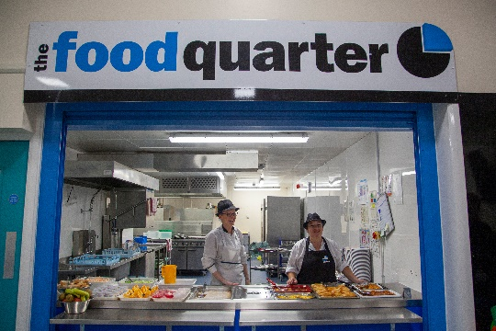

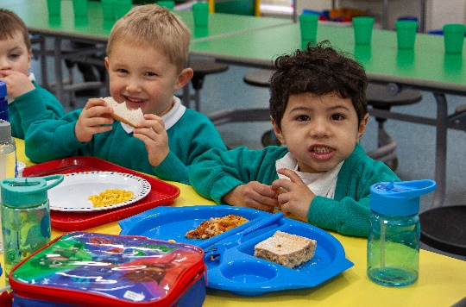
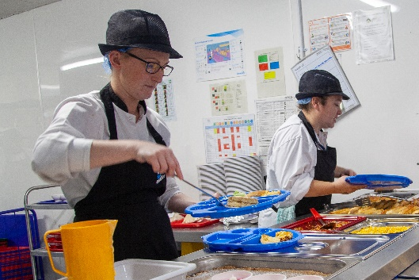

Grove House Primary School recognises the benefits of a well-balanced hot school meal for children in the middle of the day, and would recommend this to parents as the best option. However, should parents decide to send in a packed lunch from home, the following recommended guidelines set out by the British Nutrition Foundation should be noted.

Sandwich Switchers

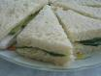
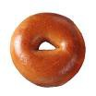
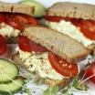
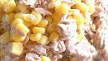
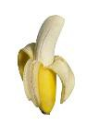
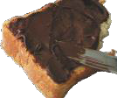
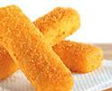
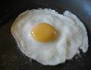
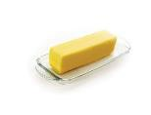
Unhealthy |  | Healthy
jam/chocolate spread |  | banana
fish fingers |  | tuna and sweetcorn
fried egg |  | egg mayonnaise and tomato
croissant |  | bagel
butter only |  | cheese or cheese spread  & cucumber

Snack Switchers

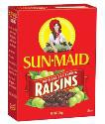
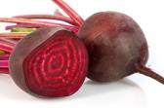
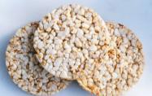
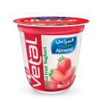
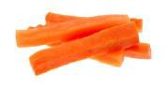
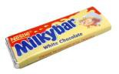
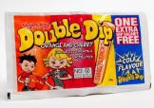
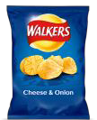
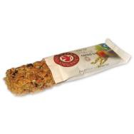
Unhealthy |  | Healthy
cereal bar |  | raisins or dried apricots cherry tomatoes
cake made with sugar/fat/muffin/pastry |  | cakes made with vegetables (beetroot, courgettes, carrot etc)
crisps |  | plain popcorn/rice cakes
Sweets/biscuits |  | carrot or cucumber sticks
chocolate bars |  | yoghurt

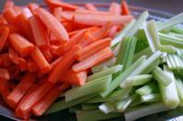
Healthy Lunchbox Ideas

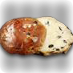
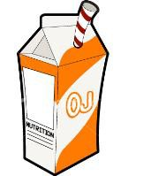

Instead of cakes, chocolates and biscuits, try currant buns (without icing), fruit bread, tea cakes and malt loaf

Freeze a carton of pure juice, milk or yogurt and place in a mini sandwich bag. It will be defrosted by lunchtime and keep your lunchbox cool in the meantime!

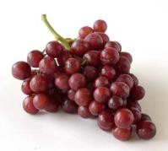
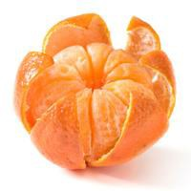
Provide fruit in small pots which is easy and quick to eat, e.g. chopped canned pineapple, satsuma pieces (peeled), raisins, dried apricots, grapes, peeled and chopped kiwi fruit
When you are preparing vegetables or salad for dinner, cut up a few extra pieces of carrot, cucumber or celery sticks for lunch the next day to reduce the time spent preparing lunch!
Making plain popcorn is easy, quick and cheap:
- Buy the kernels from any supermarket
- Place a small handful in a sealed container or covered bowl in the microwave
- Heat for about 2 minutes
- The popcorn will stay fresh for a few days in an airtight container
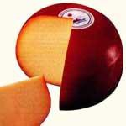
Processed cheeses (e.g. cheese strings and cheese slices) are very high in salt – cut cheddar, edam or red leicester into sticks to make it bite-size and fun to eat!

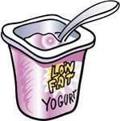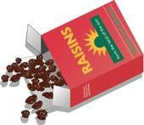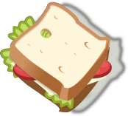
Try buying ‘whole white’ sliced bread
(white bread made with one-third wholemeal flour). Or, you could make a sandwich from one slice of whole white bread and one slice of wholemeal bread.
Make easy swaps – for example, if your child
likes something sweet, give them raisins or a small can or pot of chopped fruit instead of a chocolate bar. If they prefer savoury foods, give them plain popcorn, rice cakes or crunchy carrot sticks instead of crisps.
Keep a selection of breads in the freezer for sandwiches. Then
you can just take out what you need for one day’s lunchbox and defrost it on a plate
Using a different type of bread each day can make lunchboxes more interesting. Try granary, wholemeal or whole white bread, pitta, fruit bread, bagels, muffins, chapatti or wraps
Don’t forget the dairy – low-fat custard, fromage frais, rice pudding, yoghurts are popular and good for growing
bones.

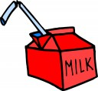
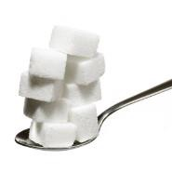
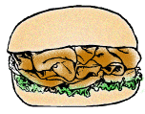
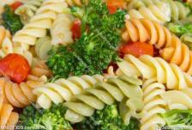
Beware Of Hidden Sugar
One large Capri Sun juice drink contains 7 ½ teaspoons of sugar! Would you put that much sugar in your tea? (One teaspoon of sugar weighs 5g)
Check the label:
- Drinks stating that they contain no added sugar will have artificial sweetener (e.g. aspartame) instead. These are not recommended for young people
- A produce is high in sugar if it contains 10g or more of sugar per 100ml. A produce is low in sugar if it contains 2g or less per 100ml.
Always include a drink to help your child concentrate. Go for still water, semi-skimmed or skimmed milk, or unsweetened fruit juice.

Cook some extra pasta, rice or
potatoes with dinner the night before to make into an effortless
and tasty salad for lunch the next day.

Pick low-fat sandwich fillings such as lean meats (e.g. ham or turkey), fish (e.g. tuna or salmon), cheese (e.g. Edam, mozzarella or cottage cheese), or sliced
banana.

A child’s lunch should include only the following:
- a portion of starchy food, e.g. wholegrain bap/bread, sesame seed pitta bread, plain crackers, pasta or rice salad
- fresh fruit and vegetables, e.g. apple/orange/banana, cherry tomatoes, carrots sticks, mini fruit chunks
- a portion of milk or dairy food, e.g. cheese, plain/fruit yoghurt
- small portion of lean meat, fish or alternative, e.g. two slices of ham, chicken, beef, Quorn, cheese, tuna, egg or hummus
- a drink - fruit juice (not fizzy or diluted squash), water (not flavoured)

The school asks that parents do not include the following items in packed lunches:
- sweets /chocolate bars
- Nuts of any type including nut based spreads (Nutella, peanut butter). We are a nut-free school
- Chocolate spread
- Sweets / chocolate bars/lollipops/chewing gum or any confectionary eg doughnuts
- Large/family size packet of crisps/quavers etc.
- Fried food
- Winders
- Cereal/cake bars
- Fizzy drinks/sugary drinks
